Security Assessment Report
Target Application Name: Altoro Mutual Online Banking Application
Target URL: http://demo.testfire.net/login.jsp
Assessment Type: Web Application Vulnerability Assessment
Assessment Date: 22/07/26(22 July2026)
Prepared By: KALI VIGNESH SM

TABLE OF CONTENTS
Section | Page No.
Document Revision History | 2
Executive Summary | 3
1. Introduction | 4
1.1 Purpose of Assessment | 4
1.2 Severity Classification | 5
i. Critical | 5
ii. High | 5
iii. Medium | 5
iv. Low | 6
v. Informational | 6
2. Assessment Overview | 7
2.1 Objectives | 7
2.3 Assessment Notes | 8
i. Test Policy | 8
ii. Tools Used | 8
3. Risk Assessment Methodology | 10
4. Detailed Findings | 12
4.1 SQL Injection | 12
4.2 Insecure Direct Object Reference (IDOR) | 14
4.3 Cross-Site Scripting | 18
4.4 Missing Login Rate Limiting | 20
4.5 Static Session Identifier (Session Fixation) | 21
4.6 HTML Injection | 22
4.7 Information Disclosure | 24
4.8 Weak Password Policy | 27
DOCUMENT REVISION HISTORY
Version | Date | Author | Description
1.0 | July 2026 | Kali Vignesh | Initial Security Assessment Report
1.1 | July 2026 | Kali Vignesh | Added findings and recommendations

EXECUTIVE SUMMARY
A security assessment was conducted on the Altoro Mutual Banking Demo Application hosted at http://demo.testfire.net. The objective of this assessment was to identify security weaknesses that could potentially impact the confidentiality, integrity, and availability of the application.
The assessment focused on evaluating the application's authentication mechanisms, input validation, session management, and common web security vulnerabilities based on industry standards including the OWASP Web Security Testing Guide (WSTG) and the OWASP Top 10 (2021).
It is important to note that Altoro Mutual is an intentionally vulnerable application developed for security education and testing purposes. Therefore, several known vulnerabilities are expected to exist.
The assessment identified multiple vulnerabilities of varying severity levels. While some findings pose minimal operational risk, others could allow attackers to gain unauthorized access, manipulate application functionality, or compromise sensitive information.
Overall Risk Rating:
High
INTRODUCTION
Purpose
The purpose of this security assessment is to identify vulnerabilities within the web application and provide remediation recommendations to improve its security posture The assessment aims to evaluate how effectively the application protects user data and resists common web-based attacks.
Severity Classification
Security findings are categorized into four severity levels based on their potential business impact and exploitability.
Critical
Critical vulnerabilities allow attackers to compromise the application with little effort. Immediate remediation is required.
Examples:
- Remote Code Execution
- Authentication Bypass
- SQL Injection leading to database compromise

High
High-risk vulnerabilities may result in unauthorized access, sensitive information disclosure, or privilege escalation.
Examples:
- SQL Injection
- Broken Authentication
- Stored Cross-Site Scripting

Medium
Medium-risk issues require specific conditions or user interaction but may still significantly impact the application.
Examples:
- Reflected XSS
- Missing CSRF Protection
- Weak Session Management

Low
Low-risk vulnerabilities have limited impact but indicate poor security practices.
Examples:
- Missing Security Headers
- Information Disclosure
- Verbose Error Messages

Informational
These findings do not directly expose vulnerabilities but represent security best practice improvements.
Examples:
- Outdated software versions
- Missing HTTP Security Headers
- Server Banner Disclosure

ASSESSMENT OVERVIEW
The assessment identified several vulnerabilities affecting the security posture of the application. The findings primarily relate to insecure authentication mechanisms, insufficient input validation, and missing security controls.
Objectives
The objectives of this assessment were:
- Evaluate authentication security
- Identify OWASP Top 10 vulnerabilities
- Assess input validation
- Review session management
- Evaluate HTTP security headers
- Detect sensitive information exposure
- Identify insecure configurations
Test Policy
The assessment was performed using a black-box testing methodology, meaning no access to source code or backend infrastructure was available. Only non-destructive testing techniques were employed.
No Denial-of-Service attacks were performed.
Tools Used
Tool | Purpose
Burp Suite Community | Proxy & Web Testing
Nmap | Port Scanning
Browser Developer Tools | Manual Testing

Risk Assessment Methodology
Risk ratings were assigned using the following criteria:
Risk | Description
Critical | Immediate compromise
High | Significant business impact
Medium | Moderate impact requiring remediation
Low | Minor impact; best practice improvements
Informational | No direct security impact

DETAILED FINDINGS

F-01 SQL Injection
Severity: Critical
OWASP Category: A03:2021 Injection
Description
The application fails to properly validate user input before constructing SQL queries.
An attacker can inject arbitrary SQL statements into database queries.
Impact
- Authentication Bypass
- Database Disclosure
- Database Modification
- Administrative Access
- Credential Theft
Proof Of Concept (POC)
- Access the /login.do page.
- Input the following payload into the Username ld:' OR '1'='1 --
- In Password, input any value.
- Submit the form.
- The backend query, typically designed as SELECT * FROM Users WHERE username = '[input_user]' AND password = '[input_pass]', is modifed to:SELECT * FROM Users WHERE username = '' OR '1'='1 --' AND password = '...' The -- comment operator nullies the rest of the query, making the OR '1'='1'condition force a successful login.

Fig 1. SQL Payload
Fig 2.Login as administrator
Recommendation:
- Validate Input by Restrict input to allowed formats
- Sanitize Input by Remove or escape special characters.

F-02 Insecure Direct Object Reference (IDOR)
Severity: High
OWASP: Broken Access Control
Description
The application allows direct access to internal object identifiers without verifying ownership.
An attacker may manipulate parameters to access another user's account or transaction details.

Impact
- Unauthorized Data Access
- Privacy Violation
- Information Disclosure
Proof Of Concept (POC)
A vulnerability was identified in the url
listAccounts parameter of showaccount caetogry in the url
(https://demo.testfire.net/bank/showAccount?listAccounts=800000). This
value can be easily changed to access other user information in the view
account savings page. By manually giving a payload either by increasing or
decreasing the value if the value exists in the database it can be easily
accessed.
A vulnerability was identified in the url listAccounts parameter of showaccount caetogry in the url (https://demo.testfire.net/bank/showAccount?listAccounts=800000).
This value can be easily changed to access other user information in the view account savings page. By manually giving a payload either by increasing or decreasing the value if the value exists in the database, it can be easily accessed.

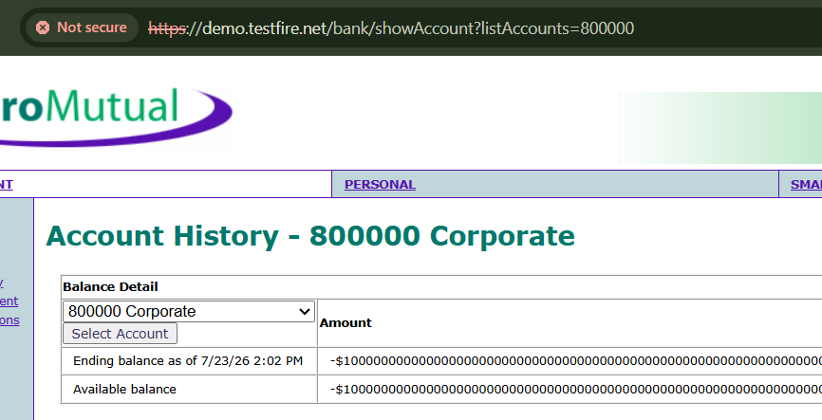
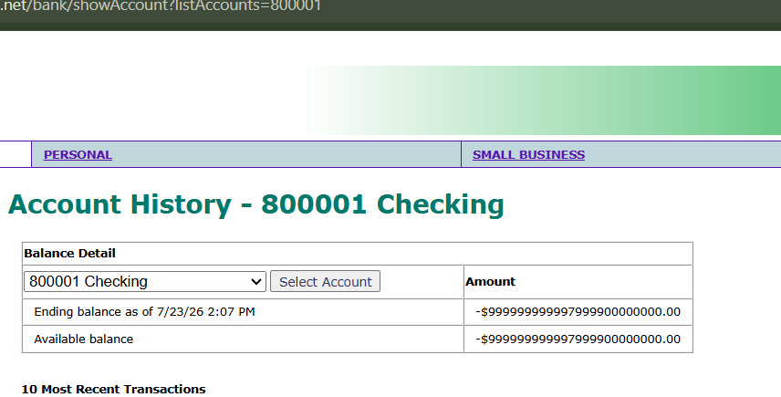

Recommendation
Implement server-side authorization checks for every request and validate resource ownership before returning data.

F-04 Reflected XSS
Severity:Medium
Description
User input is immediately reflected in the response without proper encoding.
Impact
- Cookie Theft
- Phishing
- Client-side Attacks
PoC (Proof of Concept):
I tried to search into the search box and the feedback form(in Your Name:) with this script: "<script>alert("naa oru Hacker")</script>" and ` then it displays message box
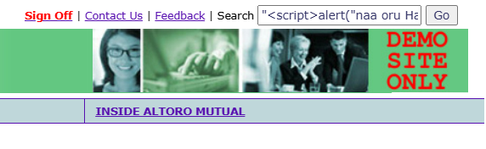
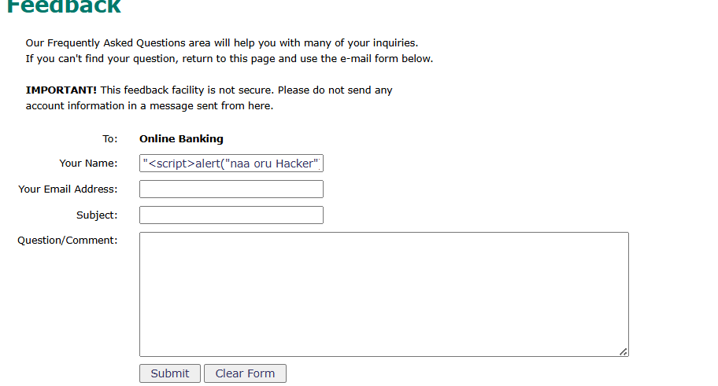

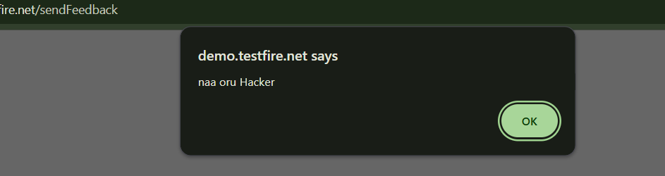
Recommendation
Output Encoding
Input Validation
F-05 Missing Login Rate Limiting
Severity: High
OWASP: Identification and Authentication Failures

Description
The application allows unlimited authentication attempts without implementing account lockout or request throttling.

Impact
- Brute Force Attack
- Password Guessing
- Credential Stuffing
PoC (Proof of Concept):
Once I intercept the HTTP login request, I sent it to the intruder to start the dictionary brute-force attack
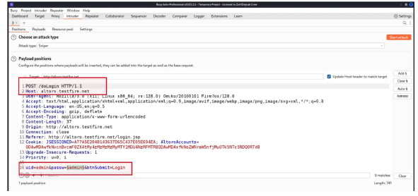
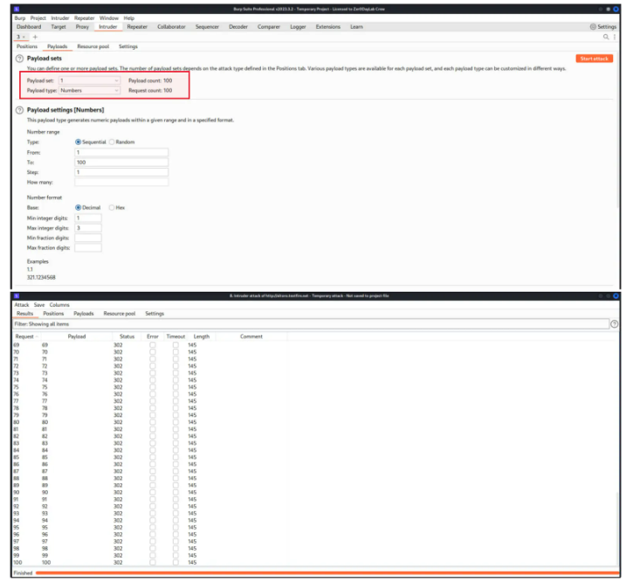
Recommendation
- CAPTCHA
- Account Lockout
- Rate Limiting
- MFA
F-06 Static Session Identifier
Severity:High
OWASP:Session Management

Description
The session identifier remains unchanged after authentication or is predictable, increasing the risk of session fixation and hijacking
Impact
- Session Hijacking
- Session Fixation
- Account Takeover
PoC (Proof of Concept):
After I logged in and out several times, I noticed the admin user has the same session id without any changes
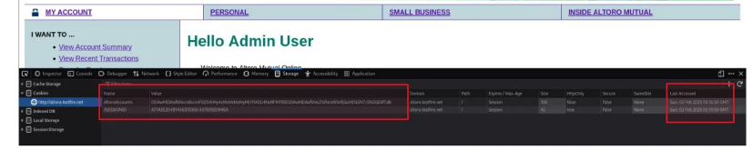
Recommendation
Generate a new, cryptographically random session ID(dynamic) after successful login and invalidate previous sessions.

